Improving the coercivity of sintered Mn-Bi magnets with a polymer coating

Youngwoon Song^{1, 2}, Jihoon Park¹, Ki-Suk Lee², Chul-Jin Choi¹
¹Powder Material Division, Korea Institute of Materials Science, Changwon, Gyeongsangnam-do 51508, Republic of Korea
²School of Materials Science and Engineering, Ulsan National Institute of Science and Technology (UNIST), Ulsan, 44919, Republic of Korea

In recent years, rare-earth-free permanent magnets have gained significant attention due to their potential for sustainable and environmentally friendly applications. Mn-Bi magnets, with their exceptional magnetic properties, have emerged as promising candidates in this regard. These days, Mn-Bi permanent magnet is one of the candidates for motor applications. The powder exhibits high coercivity (H_{c}), but there is a significant decrease in coercivity during the sintering process. This study focuses on the development of a novel approach to enhance the H_{c} of Mn-Bi sintered magnets through polymer coating techniques.
In this research, Mn-Bi sintered magnets were coated with polymers such as phenol, polyethylene glycol, and ethyl cellulose. The sintered magnets were obtained by hot-pressing process, compacted at 300°C for 20 minutes under a vacuum environment of 1*10⁻⁵ torr. The effects of the polymer coating on the magnetic properties, particularly H_{c}, were systematically investigated. Through experimental analysis, we explored the interaction between the polymer coating and the microstructure, leading to a comprehensive understanding of the coercivity enhancement mechanism.
The results of our study reveal a significant advancement in the coercivity of polymer-coated Mn-Bi sintered magnets. we observed a noteworthy increase in coercivity, increase from 5.7 kOe to 7.9 kOe. It increases by around 2 kOe, signifying a substantial enhancement in the magnetic properties of the material. However, it is noteworthy to mention that this enhancement in coercivity was accompanied by a minor decrease in remanence from 6.4 kG to 6.0 kG after the hot-pressing process for Mn-Bi sintered magnets, as can be seen in Fig. 1.
While the achievement in coercivity enhancement is noteworthy, the magnetization slightly decreases together. Therefore, this study requires optimization to maximize the maximum energy product. The optimization efforts will be directed toward refining crucial parameters, such as the selection of the polymer type and the precise quantity applied. By developing these variables, it is anticipated that the magnetic properties, especially coercivity can be further enhanced, unlocking unprecedented potential for Mn-Bi magnets in diverse sustainable applications. This study is not limited to Mn-Bi sintered magnets. It can be considered as a viable candidate for enhancing the coercivity of all permanent magnets.

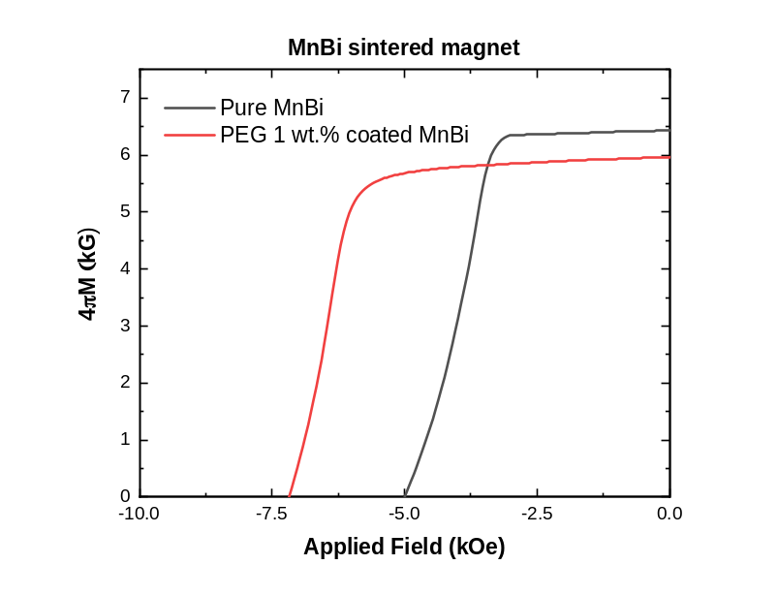
Fig. 1 Demagnetization curves of Mn-Bi sintered magnets.

